

COLLEGE of INFORMATICS and ELECTRONICS

Department of Computer Science
and Information Systems

End-of-Semester Assessment Paper

Academic Year: | 2007/2008 | Semester: | Autumn
Module Title: | Computer Organisation 1 | Module Code: | CS4211
Duration of Exam: | 2½ Hours | Percent of Total Marks: | 80
Lecturer: | Dave Burns | Paper marked out of : | 80

Instructions to Candidates:
Section 1. Answer all Multiple Choice questions: | 10 Multiple Choice Questions on a separate sheet. All questions in Section 1 are compulsory. 2 marks for each question. Circle the answer that you think is appropriate. If you wish to change your answer, cross out the circled answer and circle your new choice.
Section 2. Attempt 3 of the 4 questions.

Section 2 – Attempt 3 questions

Q1.

a. Convert 38.25 to a 32-bit floating point binary representation for a computer. (6 marks)

38 = 100110

0.25 = 0.01
38.25 = 100110.01 (1 ½ marks) = .10011001 x 2^6 (1)
Exponent is 6 = 1000 0110 Excess 128 (1)
Sign 0
0 1000 0110 0011 0010 + 15 0s
S exp Fraction missing msb (2 ½ )

A 32-bit word computer displays a memory address 0006ce28. How many bytes, and how many words, are in memory between this address and address 008084c? (4 marks)

Subtract 6ce28 from 8084c to give 13a24 bytes. (2 ½ )
Divide by 4 to give number of words: 4e89 (1 ½ )
No penalties for converting everything to decimal; but costs a lot of time, and makes you look bad

b. By drawing up a truth table, derive the Sum and Carry for a binary half-adder with inputs A and B.
(6 marks)
Get the complete range of possibilities:
A B
- 0
- 1
- 0
- 1 (2 marks)

find the sum, and the carry

- 0
- 0
1 0
- 1 (2 marks)

Sum = A’.B + A.B’; Carry is A.B (2)

Using your results, sketch a logic gate circuit that will give the outputs from the half-adder.
(4 marks)
Section 2 – continued

Q2.
a. Explain how RFID technology works, and briefly describe one active and one passive application. (10 marks)

6 marks for explanation: Radio Frequency Identification (1 mark for acronym) consists of a radio transmitter and receiver/transmitter (transponder). The tiny receiver chip is pulsed by an antenna, and the pulse powers a response back to the antenna. RFID chips have a 128 bit code which allows for a v large number, possible to be almost unique.
2 marks each for active (smart card type) application, and passive example.

b. With the aid of a sketch, explain how a hard disk drive works (4 marks)

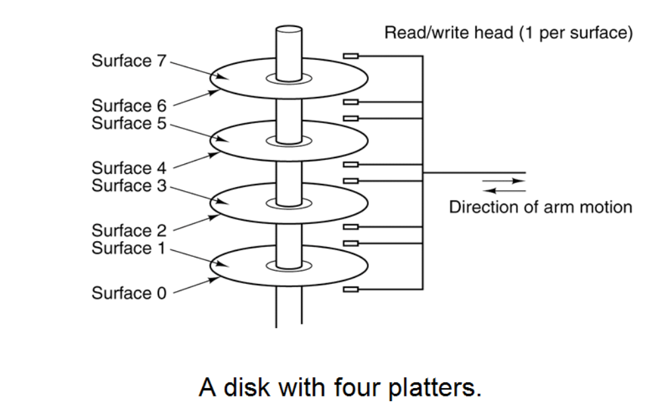
This level of art work is required for 4 marks; if you can’t draw as well as this, you need to say something also about tracks.

What are the factors which affect access speed? Explain how disk technology is designed to minimise access speed. (4 marks)

½ mark for each of latency or rotational delay, head movement and transfer rate.
Explain Cylinder concept – reading and writing data in concentric tracks in order to minimise head movement, the costliest factor. (2 ½)

Give two reasons why solid state (Flash) memory has not replaced disk memory.

(2 marks)
Price ( now rapidly converging) , reliability, and market inertia

Q3. Write brief notes on 4 of the following:
Moore’s Law and its effects

Number of transistors on chip increases at a constant rate –doubles every 18 months. Really an observation, not a law. Leads to new applications, better products and lower prices, expectations, competition, and smaller products.

LAN using Ethernet bus topology

Bus technology means that every computer is connected to every other computer on a bus, usually w coaxial cable: (1)

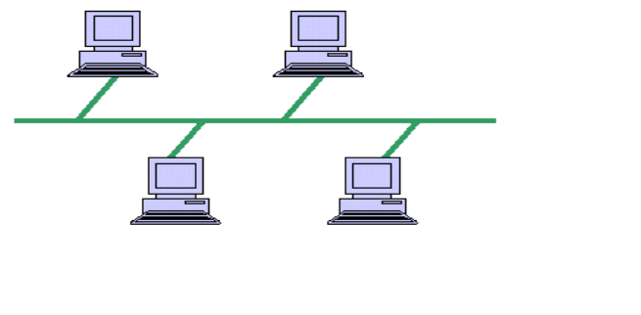

Ethernet is a set of protocols (and also used for type of equipment) which works in a ‘democratic’ fashion: it’s called Carrier Sense, Multiple Access Collision Detection – CSMA/CD. That means that a computer on the LAN looks for an opportunity to send a packet of data on to the n/w and hopes it gets to its destination. The destination computer sends a confirmation, and the sender tries to send the next packet. (2) However, if the packet collides with another packet on the bus, both packets are lost, and the senders are notified. The sending computer waits for a random interval to try to retransmit. (2) (You don’t need to remember the acronym, but be able to explain it).
(Ethernet versions today work with star topology using twisted-pair wire or fibre optic and hub. Speeds 10Mbs, 100Mbs and Gigabit Ethernet – 10 Gbs is coming)

Transformation of a high-level source program to an executable object program:

Compiler program treats source program as data; scans it for syntax errors; converts instructions to intermediate assembly language format object program; thence machine language version; links to library programs to form executable program. (1 for each stage)

RISC v CISC architecture: Load-store v instructions which can operate on memory; do all computation on register held values faster v easier programming to carry out slower operations on wider range of operands; more registers needed for RISC; RISC issues more instructions per sec; RISC new from c 1985 so need for backward compatibility to legacy systems; 50 v 150 instructions typical

The Domain Name System in the Internet

(20 marks)

Q4

a. Using the java code below, describe in detail how the system stack is used to implement the calls to the various methods in the code.

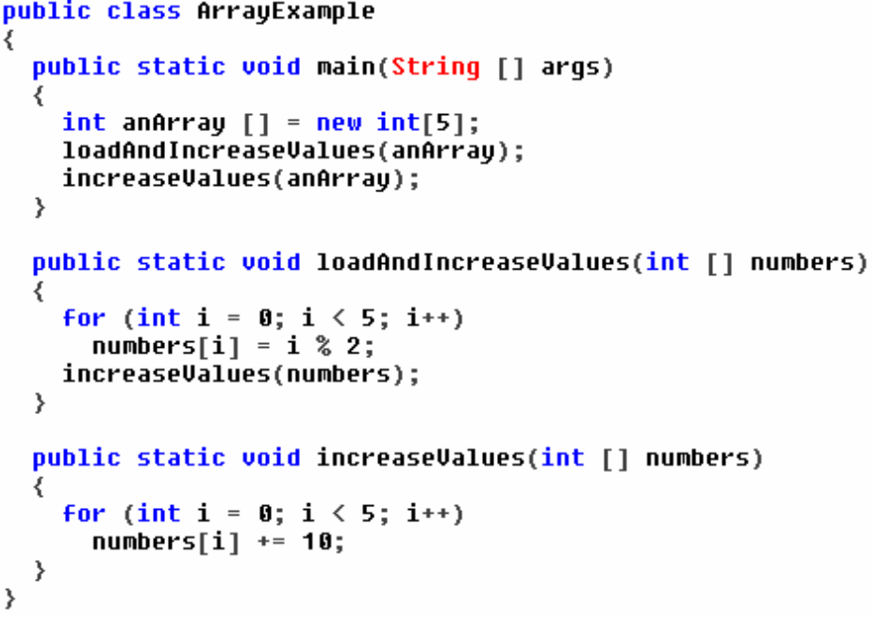

(7 marks)
Initial configuration of Stack: 5 integer values anArray go on the stack for call of main. SP points 5 words ‘higher’
Calling method loadandIncreaseValues pushes five arguments onto stack. Then copy of PC -return address - from calling method (%r15 in ARC) is placed on stack.
Now implementing loadandIncreaseValues – copy of counter i is placed on stack.

b. Describe the functions of, and the ‘relationship’ among, the three main types of volatile memory: registers, cache and RAM. (7 marks)

Registers on chip; some special purpose registers such as program counter, Program Status Register, IR. Registers take values copied from cache or memory. Fastest and most expensive. 32 or 64 registers typical
Cache close to chip or on chip; used to hold values from memory which are due to be processed. Instructions and Operands are pre-loaded into cache from RAM before processing. ½ MB to 2MB typical
RAM largest volatile memory. Slowest R/W. ½ GB to 4 GB. RAM to Cache to register.

(1 for the hierarchy; 1 for the size; 1 for another 2 points)

c. Describe either (i) an Intel Pentium Processor or (ii) a Sony Playstation - with regard to such features as registers, ALU, word size, cache memory, multimedia and clock speed. (6 marks)

